Experiment No-06
Synthesis of a 4-bit Counter using RTL Compiler
1.1 Objectives
The main objectives of this experiment are summarized as:
- To understand the standard-cell synthesis flow: translating an RTL Verilog description into a gate-level netlist using a target technology library.
- To simulate and verify a 4-bit counter design in NCLaunch/SimVision before proceeding to synthesis.
- To write timing constraints (SDC) for the design and use them to guide synthesis.
- To use Cadence RTL Compiler (rc) to synthesize the 4-bit counter, and to examine its timing and power reports.
- To view the synthesized gate-level schematic and confirm that it correctly implements the counter's next-state logic and reset behaviour.
Keywords- RTL synthesis, 4-bit counter, Verilog, NCLaunch, SimVision, Cadence RTL Compiler, SDC constraints, gate-level netlist, standard cell.
1.2 Theory
Standard-cell synthesis is the process of translating a technology-independent RTL (Verilog) description of a circuit into a gate-level netlist built from cells in a target standard-cell library, guided by timing constraints such as clock period and input/output delays. Cadence RTL Compiler (invoked as rc) is the synthesis tool used for this purpose, playing a role in the digital design flow analogous to Schematic XL and ADE L for schematic capture and simulation, and Layout XL and PVS for physical layout and verification.
1.2.1 The 4-bit Synchronous Up-Counter
The circuit under test in this experiment is a 4-bit synchronous up-counter, a sequential circuit built from four D-type storage elements that increment their combined value by one on every rising edge of the clock. The counter is given an active-low asynchronous reset: whenever the reset input is driven LOW, the 4-bit output is immediately forced to 0000 regardless of the clock, and while reset is held HIGH the counter increments once per clock cycle. Because the output is only 4 bits wide, the count naturally wraps around from 1111 (15) back to 0000 (0) on the next active clock edge, a behaviour that follows directly from unsigned binary overflow and requires no extra rollover logic in the RTL.
1.2.2 Standard-Cell Synthesis Flow
In this experiment, a 4-bit up-counter is carried through a complete standard-cell design flow: the RTL is first simulated and verified in isolation using the Incisive Enterprise Simulator (IES) through NCLaunch and the SimVision waveform viewer, then synthesized against a technology library (gpdk045, slow corner) and a set of timing constraints written as an SDC file, and finally examined as a mapped gate-level schematic, a gate-level netlist, and an SDC file ready for physical design. Cadence RTL Compiler reads the RTL and the SDC constraints, maps the design onto standard cells from the technology library, and reports the resulting timing and power figures.
1.3 Hardware/Software Used for the Experiment
1. Cadence NCLaunch (design library creation and HDL compilation)
2. Incisive Enterprise Simulator (IES) - ncvlog, ncelab, and the ncsim runtime
3. SimVision waveform viewer and Design Browser
4. Cadence RTL Compiler (rc)
5. gpdk045 technology library, slow.lib timing library (slow corner, balanced_tree wireload)
6. gedit text editor
7. Linux workstation running the Cadence design environment (csh shell)
1.4 Experimental and Simulation Analysis
A working directory was created under the user's Desktop with rtl, lib, constraints, synthesis and simulation sub-directories, following the structure used for the standard-cell flow. The counter RTL and its test bench were first written and verified in the simulation directory, then the verified module was carried forward into the rtl directory and synthesized using Cadence RTL Compiler. Each stage of this flow is illustrated below.
1.4.1 Verilog RTL Description of the Counter
The 4-bit counter was written in gedit and saved as 4-bit_counter.v, with the module named counter_4bit. The design declares a 4-bit registered output count together with clk and rst inputs, and increments count on every rising edge of clk while rst is HIGH; a negative edge of rst asynchronously clears count to 4'b0000, giving the active-low asynchronous reset behaviour described in Section 1.2.1. The complete source is given in Listing 1.
 | 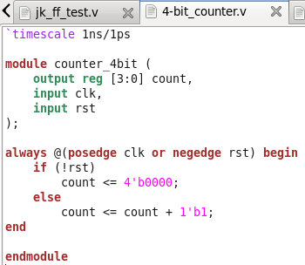
  `timescale 1ns/1ps
  module counter_4bit (
  output reg [3:0] count,
  input clk,
  input rst
  );
  always @(posedge clk or negedge rst) begin
  if (!rst)
  count <= 4'b0000;
  else
  count <= count + 1'b1;
  end
  endmodule
Listing 1: 4-bit_counter.v - 4-bit synchronous up-counter (module counter_4bit) with active-low asynchronous reset. | Figure-1.1. 4-bit_counter.v opened in gedit, showing the RTL description of the counter_4bit module.

1.4.2 Test Bench Description
A test bench, 4-bit_counter_test.v (module counter_4bit_test), was written to exercise the counter. It instantiates counter_4bit as uut, generates a free-running clock of period 10 ns using an always block (#5 clk = ~clk), and uses an initial block to hold rst LOW for the first 10 ns before releasing it HIGH for a further 170 ns, for a total run time of 180 ns. A $monitor statement continuously prints the simulation time together with rst, clk and count in both binary and decimal, so that the counting sequence can be checked directly from the Command Entry Window as well as from the waveform. The complete test bench is given in Listing 2.
 | 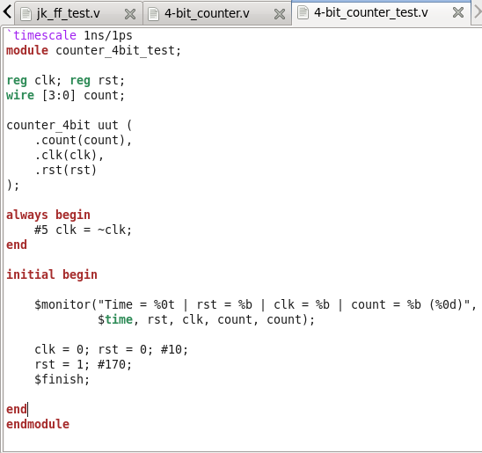
  `timescale 1ns/1ps
  module counter_4bit_test;
  reg clk; reg rst;
  wire [3:0] count;
  counter_4bit uut (
  .count(count),
  .clk(clk),
  .rst(rst)
  );
  always begin
  #5 clk = ~clk;
  end
  initial begin
  $monitor("Time = %0t | rst = %b | clk = %b | count = %b (%0d)",
  $time, rst, clk, count, count);
  clk = 0; rst = 0; #10;
  rst = 1; #170;
  $finish;
  end
  endmodule
Listing 2: 4-bit_counter_test.v - test bench for counter_4bit: 10 ns clock period, reset held low for 10 ns, then released for 170 ns. | Figure-1.2. 4-bit_counter_test.v opened in gedit, showing the clock generator, the stimulus for rst, and the $monitor statement.

1.4.3 Functional Verification using NCLaunch and IES
Both files were compiled and elaborated from NCLaunch (ncvlog, then ncelab) into the worklib library, and simulated with ncsim. Figure-1.3 shows the NCLaunch window with counter_4bit and counter_4bit_test both listed under worklib and a snapshot (worklib.counter_4bit_test:module) available to run, confirming that the design compiled and elaborated without errors before simulation was launched.
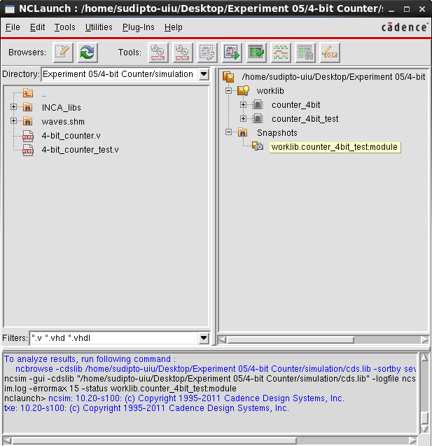 | 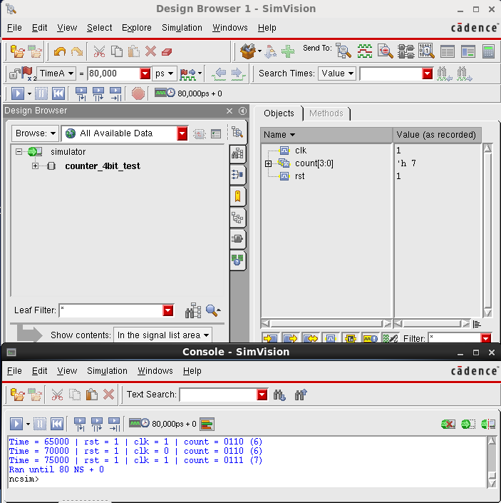
Figure-1.3. NCLaunch window showing counter_4bit and counter_4bit_test successfully compiled and elaborated into worklib, with no errors reported. | Figure-1.4. SimVision Design Browser and Console for counter_4bit_test, showing clk, count[3:0] and rst at the 80 ns cursor together with the $monitor log.
1.4.4 SimVision Waveform Analysis
The design was then simulated with ncsim -gui, opening the SimVision Design Browser and Console shown in Figure-1.4. The Objects pane lists clk, count[3:0] and rst for the counter_4bit_test instance; at the 80,000 ps cursor position, clk = 1, rst = 1 and count = 'h7, and the Console shows the $monitor output confirming that count advanced through 0110 (6) and 0111 (7) on successive clock edges, with the run reported as "Ran until 80 NS + 0" at this point in the log.

Figure-1.5 shows the corresponding waveform view from 0 to 80 ns, with count[3:0] broken out into its individual bits (count[3] down to count[0]). The clk signal toggles every 5 ns, giving the expected 10 ns period. The rst trace is LOW for the first 10 ns and then held HIGH for the remainder of the run, and count is seen to increment by one on every rising edge of clk once rst goes HIGH, stepping cleanly through the binary sequence 0, 1, 2, 3, 4, 5, 6, 7 over this window - confirming correct synchronous counting and correct asynchronous reset behaviour.
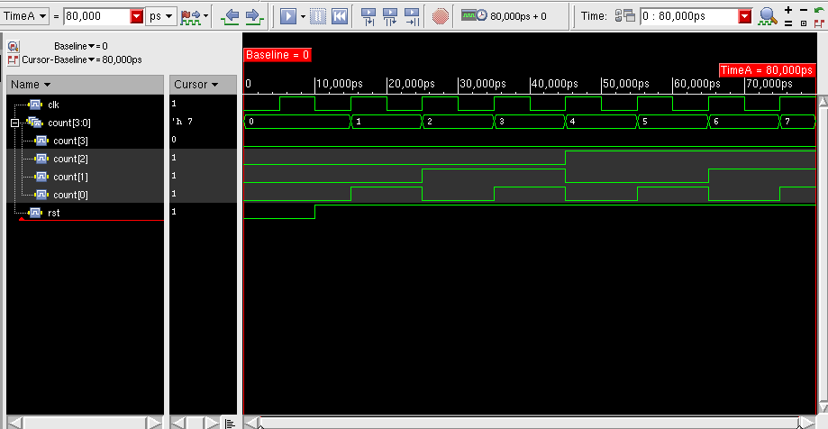
Figure-1.5. SimVision waveform for counter_4bit_test, showing clk, the individual bits of count[3:0], and rst over the first 80 ns of the simulation.
1.4.5 Timing Constraints (SDC)
A design constraint (SDC) file, cntr4bit.g, was written to guide synthesis. It defines a 10 ns clock named clk with a 0/5 ns waveform, sets a 0.1 ns clock transition on both edges and a 0.1 ns clock uncertainty, and sets a 1.0 ns maximum input delay on rst and a 1.0 ns maximum output delay on count, both relative to clk. The complete file is given in Listing 3 and is shown open in gedit in Figure-1.6.
create_clock -name clk -period 10 -waveform {0 5} [get_ports "clk"]
set_clock_transition -rise 0.1 [get_clocks "clk"]
set_clock_transition -fall 0.1 [get_clocks "clk"]
set_clock_uncertainty 0.1 [get_clocks "clk"]
set_input_delay -max 1.0 [get_ports "rst"] -clock [get_clocks "clk"]
set_output_delay -max 1.0 [get_ports "count"] -clock [get_clocks "clk"]

Listing 3: cntr4bit.g - a 10 ns clock definition, clock transition and uncertainty settings, and input/output delay constraints for rst and count.
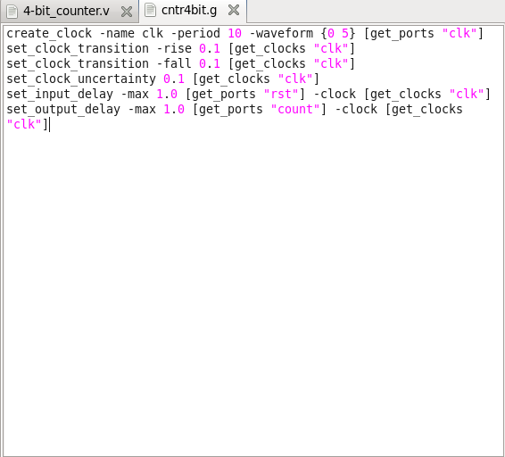
Figure-1.6. cntr4bit.g open in gedit, showing the clock definition and the I/O delay constraints.

1.4.6 RTL Compiler Synthesis Script
The verified counter RTL was copied into the rtl directory as cntr4bit.v (with the module itself named cntr4bit), matching the naming used by the constraint file and by the RTL Compiler synthesis script, rc_script.tcl. The script sets the library and search paths, reads and elaborates cntr4bit.v, reads in the SDC constraints, synthesizes the design to a mapped netlist at medium effort, reports timing and power, and finally writes out the gate-level netlist and the post-synthesis SDC. The script is given in Listing 4 and shown open in gedit in Figure-1.7.
 | 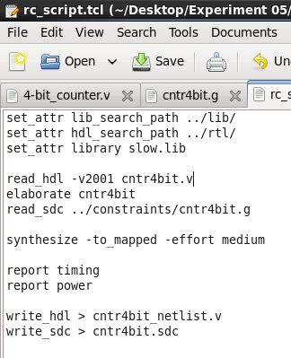
  set_attr lib_search_path ../lib/
  set_attr hdl_search_path ../rtl/
  set_attr library slow.lib
  read_hdl -v2001 cntr4bit.v
  elaborate cntr4bit
  read_sdc ../constraints/cntr4bit.g
  synthesize -to_mapped -effort medium
  report timing
  report power
  write_hdl > cntr4bit_netlist.v
  write_sdc > cntr4bit.sdc
Listing 4: rc_script.tcl - sets the library and search paths, reads and elaborates the RTL, reads the SDC constraints, synthesizes to a mapped netlist, reports timing and power, and writes out the netlist and SDC. | Figure-1.7. rc_script.tcl open in gedit, showing the complete synthesis script.
1.4.7 Pre-Synthesis File Verification
Before invoking RTL Compiler, the four required files were confirmed to be in place from the working directory using ls -lh: rtl/cntr4bit.v, lib/slow.lib, constraints/cntr4bit.g and synthesis/rc_script.tcl, as shown in Figure-1.8.
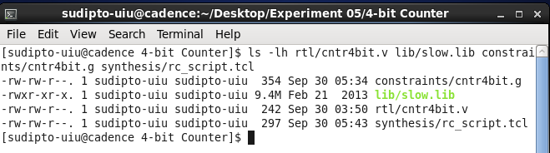
Figure-1.8. ls -lh confirming that cntr4bit.v, slow.lib, cntr4bit.g and rc_script.tcl are all present before synthesis.
1.4.8 Running Synthesis: Timing and Power Reports
RTL Compiler was invoked from the synthesis directory with rc -f rc_script.tcl. Figure-1.9 shows the resulting terminal output: synthesis succeeded (with an expected [TIM-11] warning about possible timing problems, resolved by inspecting report timing -lint), and the automatically generated timing and power reports are printed for the mapped design cntr4bit against the gpdk045bc library at the slow, balanced_tree operating condition. The critical path reported runs from the clock launch at count_reg[3]/CK through an SDFFRX4 flip-flop to the count[3] output port, with a data arrival time of 330 ps against a 10 ns clock period, leaving a comfortable positive timing slack. The key figures are summarised in Table-1.1.
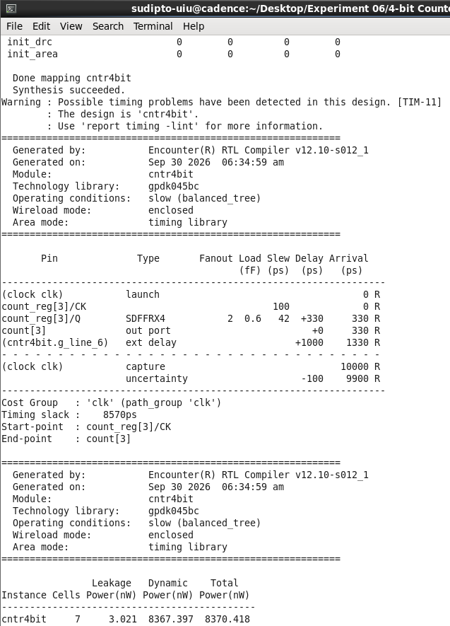 | Figure-1.9. rc terminal output at the end of synthesis, showing the timing report, the power report, and confirmation that the SDC export finished.

Parameter | Value
Technology library | gpdk045bc
Operating condition | slow (balanced_tree)
Critical path | count_reg[3]/CK -> count[3] (SDFFRX4)
Data arrival time | 330 ps
Timing slack | 8570 ps
Leakage power | 3.021 nW
Dynamic power | 8367.397 nW
Total power | 8370.418 nW
Instance cells | 7
Table-1.1. Key timing and power results for the mapped cntr4bit design (gpdk045bc, slow corner).
1.4.9 Synthesized Gate-Level Schematic
After synthesis, the mapped schematic was opened with gui_show from the rc prompt. Figure-1.10 shows a zoomed-in view of one bit slice of the synthesized cntr4bit design, with an SDFFRX4 scan flip-flop clearly labelled and the combinational XOR/AND gates that compute its next-state D input from the current count value and the carry from the lower-order bits, together with the feedback and carry-chain wiring shared with the neighbouring bit slices.
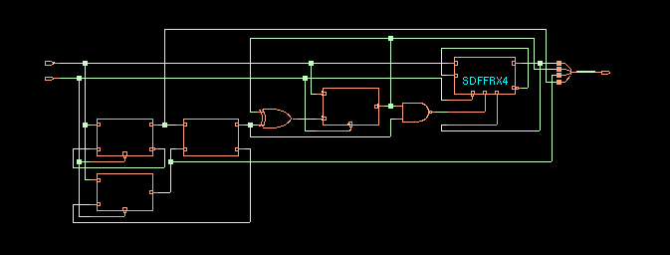 | Figure-1.10. Cadence RTL Compiler schematic view of the synthesized cntr4bit design (zoomed view), showing an SDFFRX4 flip-flop and the gates that compute its next-state D input.
1.5 Discussion
Two operating modes of the counter were observed in simulation: an asynchronous reset mode, in which rst LOW immediately forces count to 0000 independent of clk, and a synchronous count mode, in which count increments by one on every rising edge of clk once rst is HIGH. The captured waveform (0-80 ns) shows this second mode clearly, with count stepping through 0 to 7 in step with clk; since the RTL implements the increment as a plain 4-bit addition with no explicit rollover guard, the same behaviour is expected to continue through 1111 and overflow naturally back to 0000 on the next clock, consistent with the full 180 ns run reported in the test bench. The synthesized schematic was verified against this behaviour by inspection: each bit is stored in an SDFFRX4 flip-flop whose D input is driven by XOR/AND gates forming a ripple-carry increment identical in function to count <= count + 1, and the asynchronous reset port ties directly into the flip-flop's reset pin. The further RTL Compiler results - a positive timing slack of 8570 ps against the 10 ns clock and a total power of 8370.418 nW - confirm that the mapped netlist meets the SDC constraints comfortably.
1.6 Conclusion
In this experiment, a 4-bit synchronous up-counter with active-low asynchronous reset was written in Verilog, verified through NCLaunch/IES compilation and SimVision simulation, and carried through the complete standard-cell synthesis flow using Cadence RTL Compiler against the gpdk045 slow-corner library. The pre-synthesis file check, the SDC timing constraints, and the rc_script.tcl synthesis script together produced a mapped gate-level netlist built from SDFFRX4 flip-flops and simple combinational gates, whose timing and power were reported directly by RTL Compiler. The synthesized schematic was confirmed to implement the same reset and increment behaviour observed in simulation, and the reported timing slack showed that the design comfortably met the 10 ns clock constraint. This experiment provided practical, hands-on experience with the standard-cell synthesis flow that forms the basis for physical design in subsequent experiments.

